## Setup for Jetson Xavier

**1. Flashing the Jetson with WSL**

Since the Jetson board requires Linux (Ubuntu) as its base OS, we use NVIDIA SDK Manager to flash it. WSL (Windows Subsystem for Linux) on the host PC helps in running Ubuntu commands for flashing.

* Install WSL on Windows Host
* Enabled WSL feature in Windows:

wsl --install -d Ubuntu-20.04

**2. Installed NVIDIA SDK Manager inside WSL**

* Downloaded SDK Manager from NVIDIA developer site.

*https://developer.nvidia.com/sdk-manager*

**3.Connected Jetson in Recovery Mode**

* Powered off Jetson board.
* Pressed and held **Force Recovery** button for 2 to 3 sec and then **Power On**.
* Connected via USB cable to host PC.

**4. connect the usb with Wsl**

* List all of the USB devices connected to Windows by opening PowerShell in *administrator* mode and entering the following command. Once the devices are listed, select and copy the bus ID of the jetson named as (APX ) to attach to WSL.

usbipd list #list all the usb conected to the pc

* The command usbipd bind must be used to share the APX, allowing it to be attached to WSL. In my case it is showing USB serial Device (COM4)

usbipd bind --busid 1-1

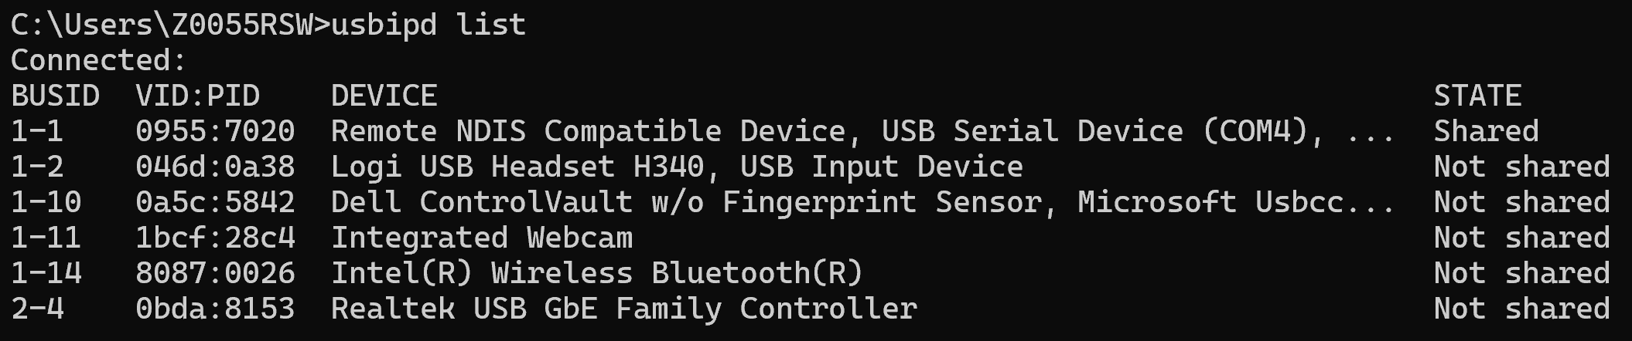

* We need to Auto attach the USB because while flashing the jetson is going to force disconnected it multiple times so, run the following command.

usbipd attach -a --wsl  --busid 1-1

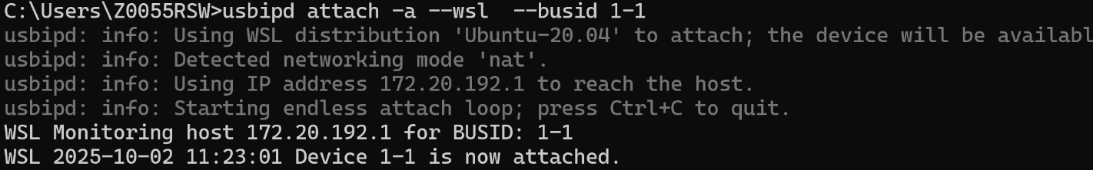

5. **NVIDIA SDK Manager**

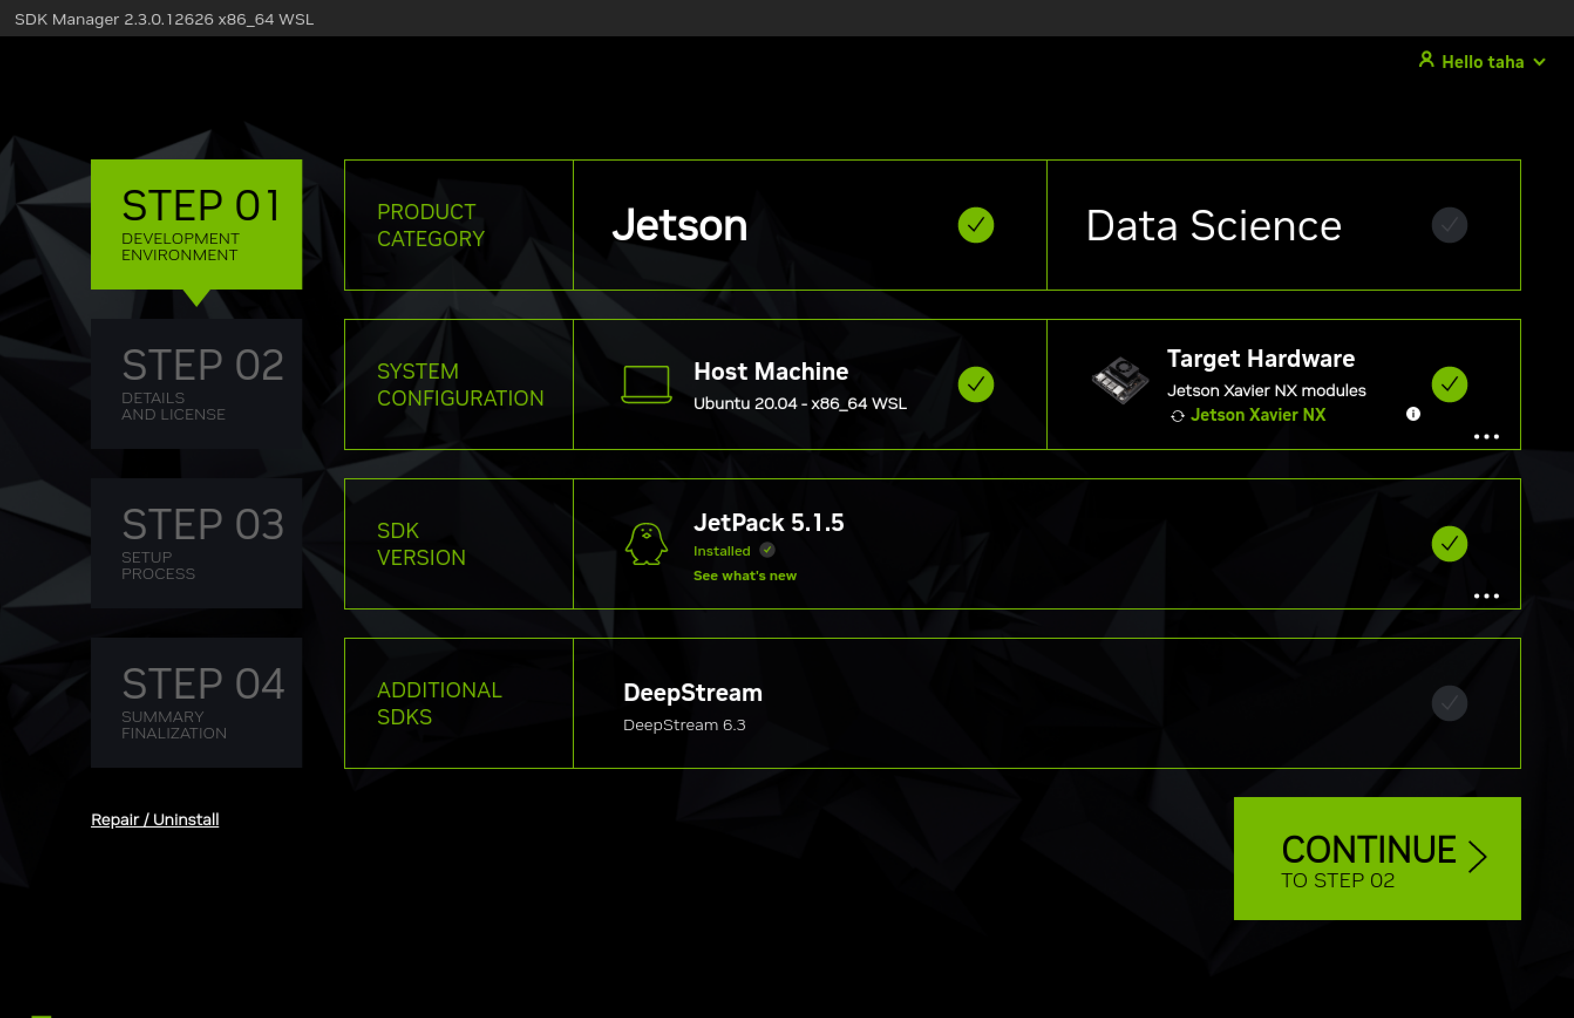

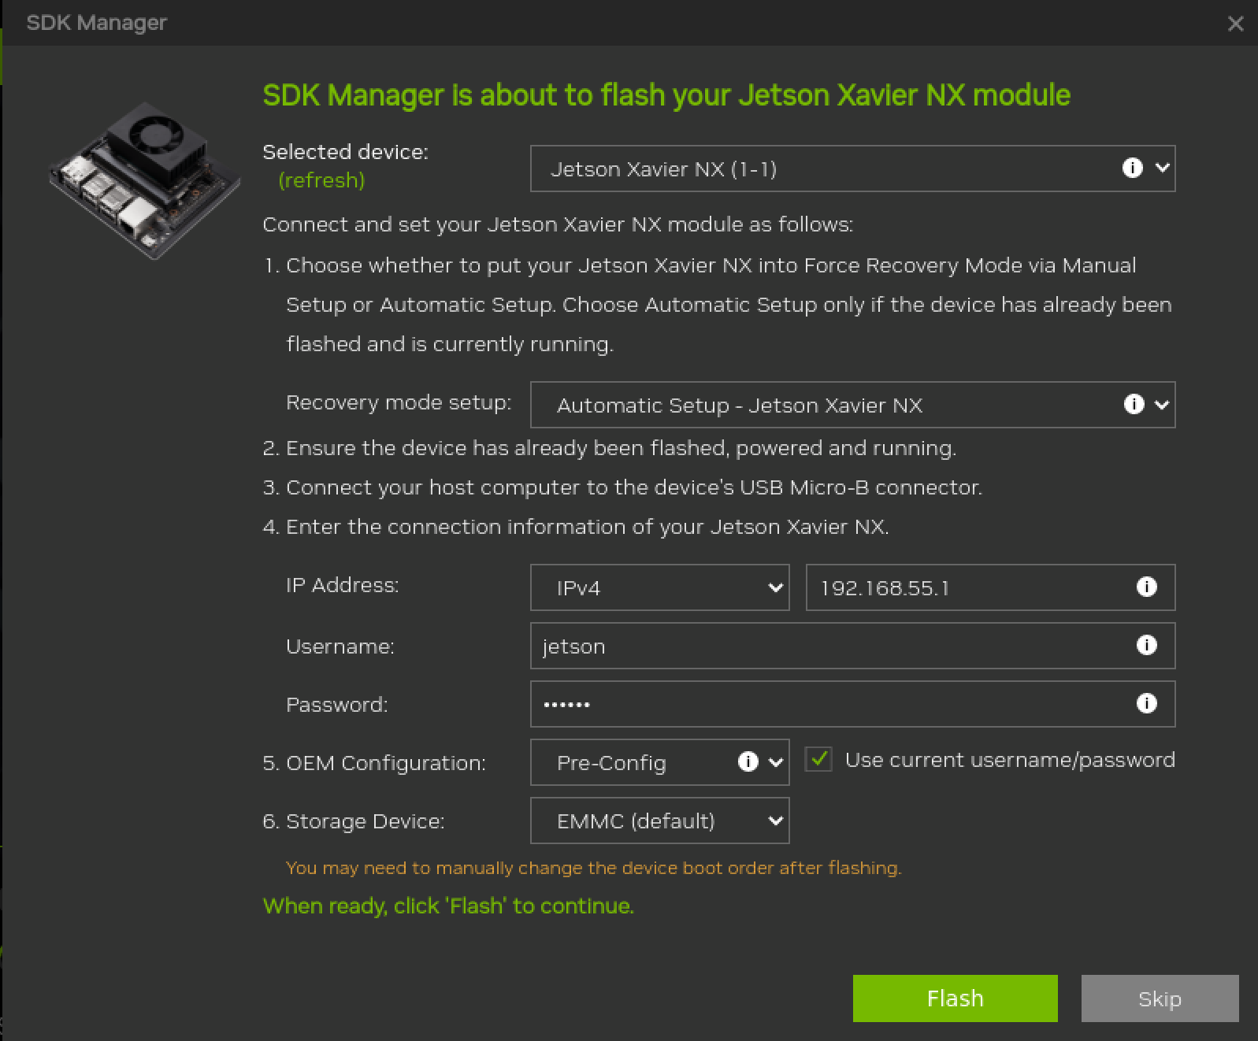

After this your jetson will be flashed and you will see this window for installation of drivers and Run time components.

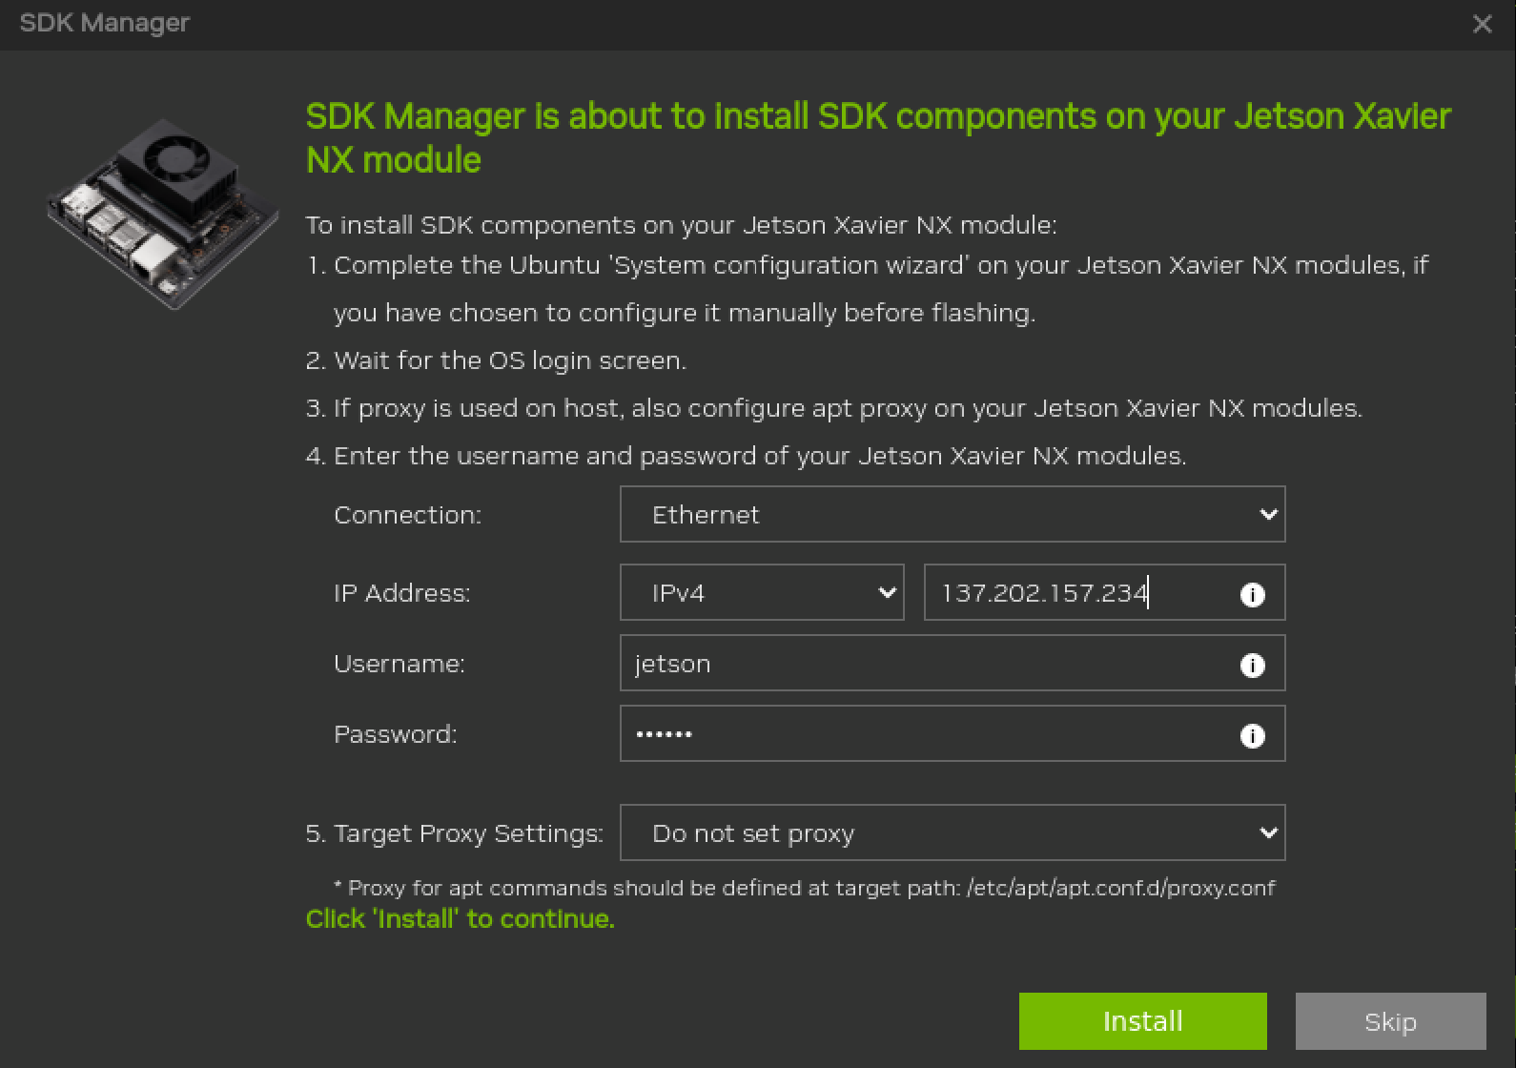

after this go to **Read me file** and see how I installed the drivers in jetson without space issue.